1. What is the accuracy, Precision, and Recall for each class prediction using feedforwardnet?

Code:

%Load DNA Data

cellDNAData= xlsread('C:\tmp\CellDNA.xls');

X = cellDNAData(:,1:13);

Y = cellDNAData(:,14);

%Normalizied all predicators

ZX=zscore(X);

% 0 = bacteria not interesting 0, 1 = bacteria interesting

for r = 1:length(Y)

if Y(r,1) > 0

Y(r,1) = 1;

else

Y(r,1) = 0;

end

end

% Solve a Pattern Recognition Problem with a Neural Network

% Script generated by Neural Pattern Recognition app

% Created 28-Jun-2017 18:05:58

%

% This script assumes these variables are defined:

%

% ZX - input data.

% Y - target data.

x = ZX';

t = Y';

% Choose a Training Function

% For a list of all training functions type: help nntrain

% 'trainlm' is usually fastest.

% 'trainbr' takes longer but may be better for challenging problems.

% 'trainscg' uses less memory. Suitable in low memory situations.

trainFcn = 'trainscg'; % Scaled conjugate gradient backpropagation.

% Create a Pattern Recognition Network

hiddenLayerSize = 10;

net = patternnet(hiddenLayerSize, trainFcn);

% Setup Division of Data for Training, Validation, Testing

net.divideParam.trainRatio = 90/100;

net.divideParam.valRatio = 5/100;

net.divideParam.testRatio = 5/100;

% Train the Network

[net,tr] = train(net,x,t);

% Test the Network

y = net(x);

e = gsubtract(t,y);

performance = perform(net,t,y)

tind = vec2ind(t);

yind = vec2ind(y);

percentErrors = sum(tind ~= yind)/numel(tind);

% View the Network

view(net)

% Plots

% Uncomment these lines to enable various plots.

%figure, plotperform(tr)

%figure, plottrainstate(tr)

%figure, ploterrhist(e)

%figure, plotconfusion(t,y)

%figure, plotroc(t,y)

**Class1:**

Accuracy = 92%

Precision = 96.3%

Recall = 94.3%

**Using Patternnet**

**Performance:**

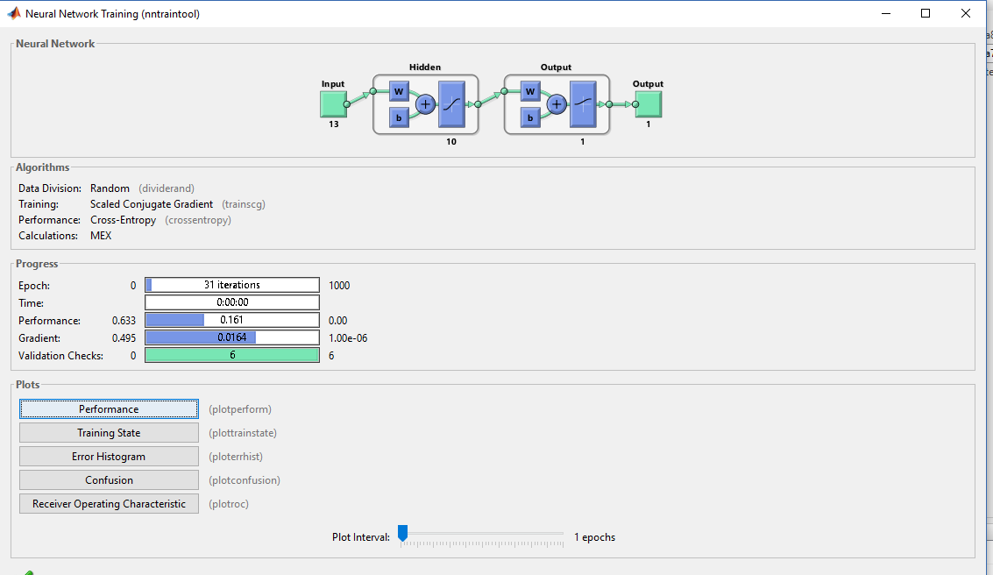

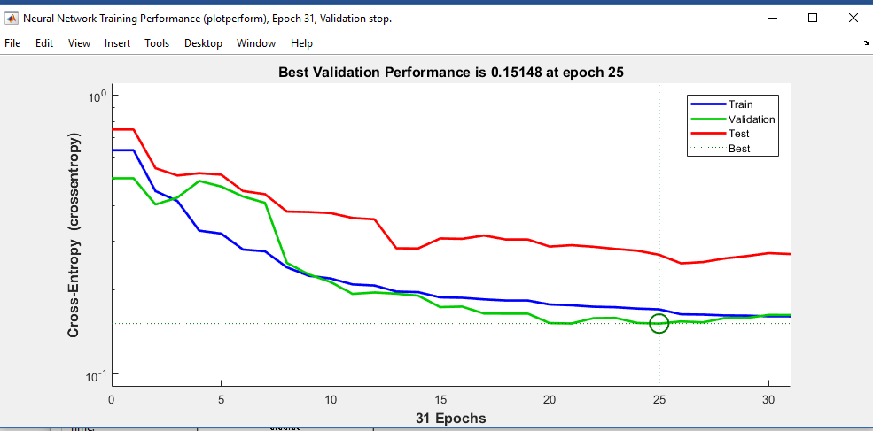

**Confusion Matrix:**

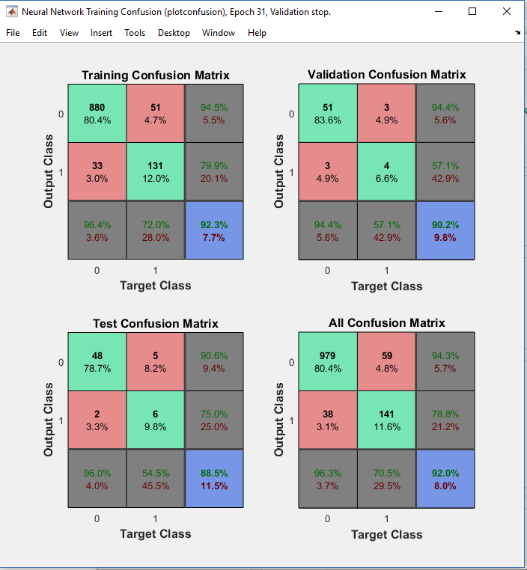

1. **Create an ROC curve plot for each class prediction.**

